**NATURAL SUN PROTECTION EFFECT OF SILK PEPTIDES**

Şebnem Küçük 1, Ufuk Koca Çalışkan 2

*1Febs Biyoteknoloji, Kızılırmak mah.1431. cad 27/2*, *Ankara-TURKEY*

2 *Gazi University, Faculty of Pharmacy, Department of Pharmacognosy, 06330, Ankara-TURKEY*

*Corresponding author e-mail*:[***ukoca@gazi.edu.tr***](mailto:ukoca@gazi.edu.tr)

**Abstract**

In current years, the harmful effects of the UVA wavelengths of sunlight have been causing more serious conditions such as dermological problems and moreover skin cancers. Sun protection products have been the focus of human being, especially for kids. Many Sun protection products have long been used to protect against sun light induced erythema with the performance indicated by the sun protection factor (SPF). Silk, is one of the natural material having SPF, which originally came from China, known as a luxury fabric in the whole world. Scientists had been very curious about the silk structure, recently, silk fiber and silk amino acids became the center of an important research topic for biotechnology. Silk is made of two peptides that are sericin and fibroin. Sericin appears to beneficially affect the skin as a protective (anti-oxidation, anti-UV radiation) and as a rich moisturizer agent. These effects may be seen with both oral and topical applications.

In this study, we aim to demonstrate the UV efficacy of silk peptides by using two SPF creams with same formulas except, one of them is enriched with silk peptides. As a result, SPF cream with ‘**silk peptide’** scan was recorded as **SPF 50.87**, T(UVA) 8.68%, T(UVB) 1.52%, lambda critical 378.92 (number of scans :12, UVA/UVB ratio= 0.699). Whereas, scan results of the SPF cream without silk peptide were **SPF 39.31**, T(UVA) 6.71%, T(UVB) 2.27%, lambda critical 382.08 (number of scans :12, UVA/UVB ratio= 0.795)

It was observed that the silk peptides have a strong protective property, especially in terms of UVA activity. UVA radiation is the main concomitant cause of skin photosensitization and phototoxicity, whereas, UVB radiation has been known for immediate and evident skin damages. Therefore, besides all these benefits of silk peptides in cosmetics, it can also be used as a natural UV protectant.

**Introduction**

Due to the damage on the ozone layer, sun lights are causing more and more serious conditions such as dermalogical problems and variety of skin cancers. Sun protection products have been the focus of human being, especially for kids.

The sun emits three different types of UV radiation: UVA UVB and UVC. Although all types of the UV radiation have potentials to damage the skin, each type have effects on human skin different ways. UVC, the shortest of all UV rays, never reaches the earth, since it was absorbed by ozone. UVB, the chief cause of skin reddening and sunburn, tends to damage the top layers of the skins. UVA, accounts for 95% of the UV radiation that reaches the earth. Plays a major part in skin agining and wrinkling since penetrates the skins’ second layer.

Various sun protection products have long been used to protect against sun light induced erythema with the performance indicated by the sun protection factor (SPF). Sunscreen products contain active ingredients that can absorb, reflect or scatter the sun light, depending on their nature.

UVA radiation damages skin cells and DNA, being responsible for photo aging and photo carcinogenesis. Both UVA and UVB can cause sunburn, photoageing, erythema and inflammation (Wang 2001). The effects of UVA only manifest after a long period of exposure, even if the doses are low. UVA contribute for reduction of skin elasticity, increase of wrinkling and production of reactive oxygen that leads to acute and chronic changes on the skin. Moreover, they cause aggravation of cutaneous lupus erythematosus and also cause immunosuppression that contributes to the growth of skin cancer UVB radiation causes some changes, such as pigmentation and sunburn, as well as chronic changes, such as immune suppression and photo carcinogenesis.

Each year, further new cases of skin cancers are diagnosed in the U.S. than new cases of breast, prostate, lung, and colon cancer combined. One in five Americans will develop skin cancer in their lifetime. According to literature one American dies from skin cancer every hour ([www.aad.org](http://www.aad.org)) Unprotected exposure to UV radiation is the most preventable risk factor for skin cancer. To protect the skin from the sun, sun screen products are applied mostly on skins to avoid all of the aforementioned damaging effects. (Svobodová and Vostálová 2010)

Sunscreens have an individual sun protection factor (SPF) value, that is defined as the ratio of the minimal erthemal dose on sunscreen protected skin (MEDp) to the minimal erythemal dose (MEDu) on unprotected skin, as showed on equation.

*SPF*= $\frac{minimal erythemal dose in sunscreen protected skin}{minimal erythemal dose in unprotected skin}$

Topical sunscreen agents can be divided into organic and inorganic agents.



*(Latha and Bangere, sunscreen agent:reviews,2013)*

The formulation that are commercially available include a combination of these agents to cover a wide spectrum of UV radiation. This sunscreen agents action may vary from blocking, reflecting and scattering light. An ideal sunscreen agent has to be safe, chemically inert, nonirritating, nontoxic, photo stable and should provide complete protection to the skin. (Lionetti and Rigano 2017)

Silk is one of the natural material having SPF which is a fine, strong, soft lustrous fibre produced by silkworms in making cocoons and collected to make thread and fabric. The domesticated silkworm is an important economic insect (Figure 1-A). The silkworm produces massive amount of silk proteins during the final stage of larval development. These proteins are stored in the middle silk gland and they discharged through the anterior duct and spinerret.

Silk protein represent a unique family of natural fibrous proteins due to their unique structure. It’s major components are fibroin and sericin (Figure 1-B). Fibroin is a fibrous protein constituting the core of silk, while sericin is a glue like protein that envelopes fibroin fibers.

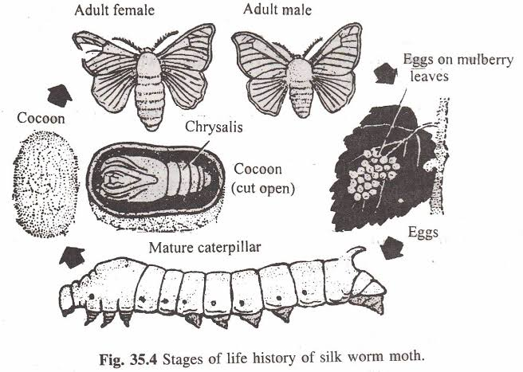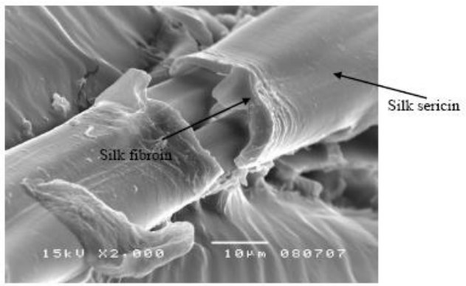

B

A

Figure 1. A: A general life cycle of the silkworm (*Bombyx mori*), B: Scanning electron microscope (×2000) image of silk fiber that contains sericin and fibroin (Aramwit 2015)

**Material and Methods**

Two different SPF creams with same formulas but one of them was enriched with silk peptides. UVA protection factor and “critical wavelength” values were evaluated with *in vitro* UV protection method, which is called “Colipa”. This method provides two metrics describing the UVA protection of a sunscreen. (2006/647/EC)

|  |  |
| --- | --- |
|  | * **Measurement parameters:** *In vitro* SPF, UVA/UVB ratio, critical wavelength * **Method:** Colipa * **Software**: UV-2000S * **Lamp**: Xenon flash lamp * **Measurement Range:** 250-450 nm wavelengths * **Plate:** PMMA HD-2 * **Surface area:** 50x50 mm * **Permeability:** 0-100% * **Absorbance:** 0-2.7 A (read at 1nm intervals for 12 points). |

**Methods:**

STEP 1: *In vitro* transmission measurement of the sunscreen product was spread on a PMMA plate, prior to UV irradiation.

STEP 2: Acquisition of initial UV spectrum with AO (λ) data. An *in vitro* SPF (0%UV dose) equal to the labelled SPF (*in vivo*). UVAPF0 is calculated using AO (λ) and C.

STEP 3: A single UV dose D is calculated, proportional to UVAPF0.

STEP 4: UV exposure of the same sample as in step 1, according to the calculated UV dose D. STEP 5: *In vitro* transmission measurement of the sun screen product after UV exposure. Acquisition of second UV spectrum with A (λ) data.

STEP 6: Mathematical adjustment of the second spectrum (following UV exposure) according to the same C coefficient, previously determined in step 2. Calculation of the *in vitro* UVA protection factor UVA-PF after irradiation using A (λ) and C and calculation of the critical wavelength value from A (λ) data.The wavelength range measured by the spectrophotometer (290 to 400 nm). The substrate / plate is the material to which the sun screen product sample is applied (made by polymethylmethacrylate -PMMA).

Firstly, the method provides in vitro UVA protection factors (UVA-PF), which have been shown to correlate well with *in vivo* UVA protection factor values derived from the persistent pigment darkening (PPD) method. Secondly, the method also provides a means of calculating critical wavelength values. The test is based on an assessment of the UV transmittance of a thin film of sunscreen sample spread on a roughened substrate after exposure to a controlled dose of UV radiation from a defined UV source. Due to the current lock of inter laboratory reproducibility of absolute in vitro UV measurements, each set of sunscreen transmission data is adjusted by first converting to absorption data and then by multiplying by a correction coefficient.

Both the final in vitro UVA-PF and in vitro critical wavelength value, are calculated from the absorbance data of the UV exposed sample

**Results**

As a result, SPF cream with ‘**silk peptide’** scan were **SPF 50.87**, T(UVA) 8.68%, T(UVB) 1.52%, lambda critical 378.92 (number of scans :12, UVA/UVB ratio= 0.699). Whereas, scan results of the SPF cream without silk peptide were **SPF 39.31**, T(UVA) 6.71%, T(UVB) 2.27%, lambda critical 382.08 (number of scans :12, UVA/UVB ratio= 0.795) all those data indicate that the test was performed in a safe range.

SPF value is very important for the study. The result of the SPF value of sunscreen with silk protein was found to be 50,87. the other sample was measured 39,31.

**Conclusion:**

It was observed that the silk peptides have a strong protective property, especially in terms of UVA activity and it contributed to the increased homojenity of the formulation. UVA radiation is the main cocomitant cause of skin photosensitization and phototoxicity, whereas, UVB radiation has been known for immediate and evident skin damages. Therefore, besides all these benefits of silk peptides in moisturizing cosmetics, it can also be used as a UV protectant

|  |  |
| --- | --- |
| Comparison of sunscreen potential of both cream formulations | |
| Sunscreen cream+ silk protein | Sunscreen cream only |
| page3image66826224 | page3image66387184 |
| Sunscreen with silk | Sunscreen only |

**Conclusion:**

It was observed that the silk peptides have a strong protective property, especially in terms of UVA activity and it contributed to the increased homojenity of the formulation. UVA radiation is the main cocomitant cause of skin photosensitization and phototoxicity, whereas, UVB radiation has been known for immediate and evident skin damages. Therefore, besides all these benefits of silk peptides in moisturizing cosmetics, it can also be used as a UV protectant

**References**

American academy of dermatology association, [www.aad.org](http://www.aad.org)

Aramwit, P; (2015). In: Wound Healing, BIOMATERIALS FOR WOUND-HEALING APPLICATIONS, Editor: Lacie E. Wade Nova Science Publishers, Inc. Chapter 4, pages 49-104, ISBN: 978-1-63463-455-7

Commission recommendations of 22 September 2006 on the efficacy of sunscreen products and the claims made relating thereto (2006/647/EC). Official Journal of the European Union. 26.9.2006.265/39-265/43.

Latha M.S. and Bangera S.; (2013) Sunscreen agents: review JCAD journal of clinical and aesthetic dermatology.

Lionetti, N and Rigano, L; (2017). The New Sunscreens among Formulation Strategy, Stability Issues, Changing Norms, Safety and Efficacy Evaluations , 16 May

Svobodová A. and Vostálová J.; (2010). Solar radiation induced skin damage: review of protective and preventive options, Inernational journal of radiation Biology, December

Wang SQ, Setlow R, et al. Ultraviolet A and melanoma: a review. J Am Acad Dermatol. 2001:837–846.